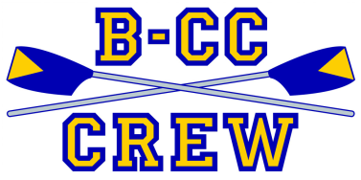
Customer Order Form
Thank you for your Support of the
BCC High School Crew Team!
ATHLETES: PLEASE MAKE COPIES AND FILL OUT FOR EACH CUSTOMER.
DEADLINE: Nov. 15

UNDECORATED  WREATH ($23)  Double-sided, fragrant 22” natural balsam fir wreath with velvet bow | BOXED / DECORATED WREATH ($32)  Beautiful 22” natural balsam fir wreath decorated with clusters of pine cones, red holly berries and a velvet bow | CHANUKAH CANDLES ($20)  Beautiful blue/white,  6-inch hand-dipped  Chanukah candles  (44 candles/box)
Quantity: | Quantity: | Quantity:

TOTAL AMOUNT DUE:

Checks can be made to “BCC Crew Boosters”
Orders may also be placed online until Nov. 11
at www.bcccrew.org

Please fill in information clearly:
Customer Name:
Customer Address:
Customer Telephone:
Customer Email:
Crew Member Name:
Crew Member Telephone:

ATHLETES: PLEASE MAKE COPIES AND FILL OUT FOR EACH CUSTOMER.
Customer Receipt
Athletes: please fill out info, detach and leave receipt with your customer

Your products will be delivered to your home
shortly after Nov. 26
# Undecorated Wreaths Ordered:
# Decorated Wreaths Ordered:
# Boxes of Candles Ordered:
TOTAL $ AMOUNT RECEIVED:

Please fill in information clearly:
Crew member’s Name:
Crew Member’s Telephone:

www.bcccrew.org
Info/questions: please contact
Katherine Grover at 301-526-4988 or ksg4601@gmail.com
OR Anya Nebel at 301-741-0177 or anebel1@me.com
Thank You for Supporting
the BCC Crew Team!

